Summarising Data

**Learning Objectives**

* Be able to produce and interpret the SPSS outputs used to summarise data
* Be able to choose the most appropriate output to describe a distribution
* Be able to write a rudimentary report to describe a distribution

OUTPUT FOR Fruit_Veg_&_Exercise.sav

FREQUENCIES OUTPUT**:** [categorical variables]

**Self-Assessed Health Status**

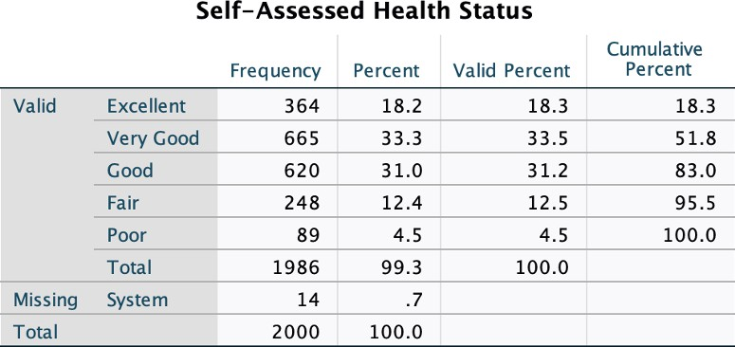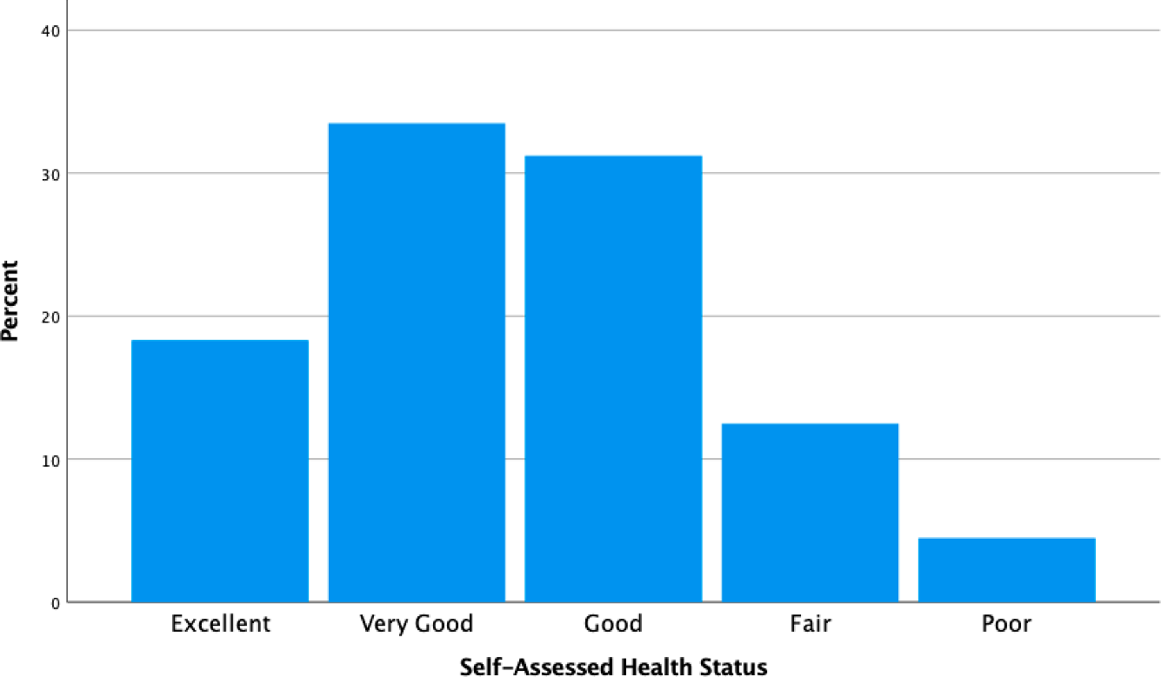

# Reporting the distribution of a categorical variable:

The distribution of Self-Assessed Health Status for a sample of **1986** respondents is displayed in

Figure 1. The most typical reported health status in this sample was **Very Good** ( **33.5**%),

followed by **Good** ( **31.2** %). While **18.3** % of respondents reported excellent health,

only 12.5 % reported fair health, and very few respondents reported being in poor health.

EXPLORE OUTPUT: [metric variables]

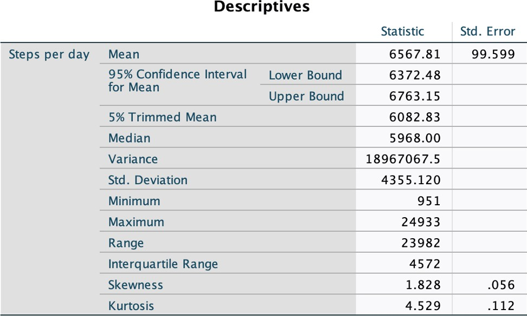**Steps per day**

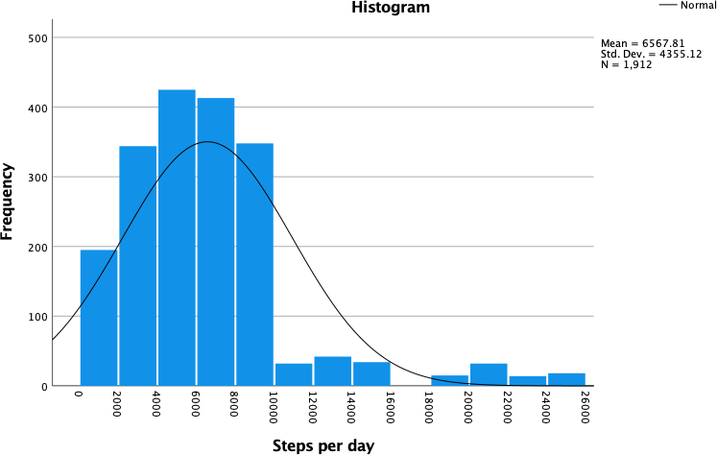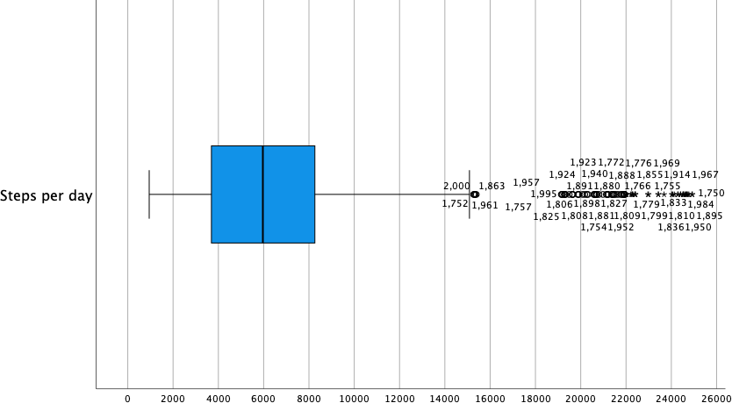

# Reporting the distribution of a metric variable:

As this distribution is skewed, we need to report the median not the mean.

The distribution of the number of steps per day in a sample of **2000** respondents is displayed in Figure 1. The distribution is **positively skewed** with 50% of steps per day being **5968**

or more (or less). **Typically**, steps per day were between 3691.25 and

**8263.25** , with half of the steps per day falling within this range. Some respondents reported exceptionally high numbers of steps per day, of over 14804.25, with the highest being

24933 steps per day.

Complete the table below, indicating if the variable listed is Categorical or Metric, as well as the procedure required [Frequencies or Explore] to produce the most appropriate output:

|  |  |  |  |
| --- | --- | --- | --- |
| **Variable** | | **Categorical OR Metric?c** | **Frequencies OR Explore?** |
| a. | Test Result:  [score out of 100] | Metric | Explore |
| b. | Music Preference:   1. Jazz 2. Classical 3. Popular 4. Grunge 5. Heavy Metal 6. Other | CATEGORICAL | FREQUENCIES |
| c. | Wellbeing:  Scale of 0 to 25 | METRIC | EXPLORE |
| d. | Test Result:   1. Pass 2. Credit 3. Distinction 4. High Distinction | CATEGRICAL | FREQUENCIES |
| e. | Weight [kgs] | METRIC | EXPLORE |
| f. | Height [cm] | METRIC | EXPLORE |
| g. | Weight:   1. Underweight 2. Normal range 3. Overweight 4. Obese | CATEGORICAL | FREQUENCIES |
| h. | Use of Public Transport   1. Never 2. Sometimes 3. Always | CATEGORICAL | FREQUENCIES |
| i. | Length of Stay [days] | METRIC | EXPLORE |
| j. | Coffee Consumption  [cups per day] | METRIC | EXPLORE |

.

**Foundations of Statistics – Laboratory Class 3**

